WALK 4: WAREHAM QUAY TO SANDFORD
Ordnance survey map: OL15 Grid reference: start SY 923 871 finish SY 932 899
Transport (check current timetables):
Bus: Purbeck Breezer 40 Poole/Swanage.
South West Trains: Poole, Bournemouth, Wareham and Holton Heath stations.
Car Parking: Streche Road and Conniger Lane (off Church Lane) car parks (pay) also Bonnetts Lane car park (pay); side roads in Sandford.
Approximate distance: 12 km, 7½ mls allow 4 hours.
Facilities en route: refreshments in Wareham, toilets at Wareham Quay and Howards Lane.
Nature of route: riverside path and heathland; some roads, no stiles.
Special interest: River Frome and Wareham’s Saxon Walls.
Connecting trails: Purbeck Way, Purbeck Way West, Wareham Two Rivers Walks, Wareham Forest Way, and the Northport Greenway all link to this walk. (Leaflets available from Tourist Information Centres in Swanage and Wareham.)
Connecting harbour walks: Walk 4a - Wareham Station, Wareham Forest and West Mills; Walk 4b – Wareham Station and Wareham Forest; Walk 4c – Wareham Quay, Rivers Frome and Piddle; Walk 4d - Wareham Quay and Wareham Walls.
Note: a compass would be useful.

- Take the 40 Purbeck Breezer Poole/Swanage bus to Wareham Quay. Starting at the Quay in Wareham, head for the far left hand corner of the Quay (as viewed from the road) and go through a short alley to Church Green and the church.
Pass the church on your right and follow the churchyard wall around to the right. At the end turn right into a lane which turns left then right around a pumping station.

- After a long wooden boardwalk and when you come to a junction of paths with some fencing and a hand gate ahead, go straight through the gate and continue ahead. Join the river bank path signed ‘River path’ and follow this path for about 3 km. In winter and at times of high tide, the footpath along the river can be flooded.

- Ignore a sharp left hand turn of the path and then carry on until the path reaches nearly the edge of the harbour and turns left. Soon after you will pass through a gate and enter open ground. Keep left and continue for about 2 km with the woods on your left (W).
- When you reach a gate on your left leading onto a lane, follow the lane until you reach a point where the lane turns sharp left alongside the base of the Wareham Walls.
- Follow the path up onto the Wareham Walls and continue along the top to the right.
- The path turns left and at the end joins a road. Go down onto the road and turn right (NNW) to join the main road into Wareham.
Turn right and cross the bridge over the River Piddle. Take the pedestrian underpass towards the station.

- Cross over the railway line to the bus shelter. Take the path which is on the opposite side of Bere Road to the bus stop. This is signed as a cycleway/footpath. Follow it and after it bears left it joins an estate road, go straight over and keep alongside the open space (N). Keep to the right of the open space and pass through a narrow entryway between the houses. At the road turn left.

- In a short distance turn right onto a cycleway leading towards the golf course (NW). Follow this track through the golf course avoiding several forks and cross paths leading on to the golf course. Soon you reach a barrier leading into Wareham Forest.

- Turn right (NE) keeping to the boundary fencing on your right. This wide track winds around for some distance. You will pass a seat and come to a junction of several tracks.
- Turn right (E) to go over the bridge. Once over the bridge bear left (N).

- Follow the wide track round a long left bend and up a small rise. The track winds around a hill turning to the right (ENE). Continue ahead, passing a cross track.
- Cross the road from Sandford. Go straight on over the heath (ENE) to the woods.
- Turn right (SSE) at the junction into the nature reserve.
- After several boardwalks you will come out into an estate road in Sandford. Turn left and follow the road around, passing a road on your right. You will turn to the right then left and finally you will come to a short footpath on a bend leading off to the left onto the A351. Catch a 40 Poole/Swanage bus from here.
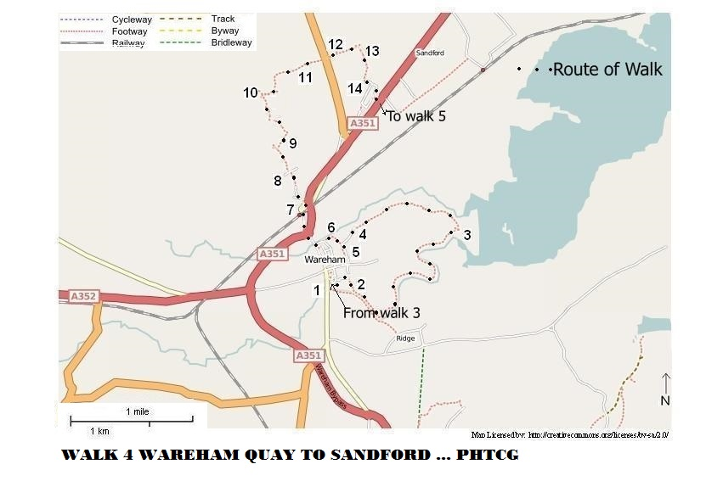

Further detail of the beginning of Walk 4:

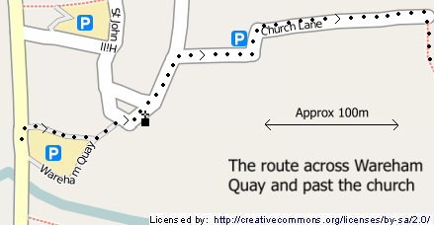

Maps reproduced from http://www.openstreetmap.org/index.html

Revised 16/10/21

