WALK 3: PURBECK PARK (formerly Norden Park and Ride) TO WAREHAM
Ordnance survey map: OL15 Grid reference: start SY 954 828 finish SY 923 871.
Transport (check current timetables):
Bus: Purbeck Breezer 40 Poole/Swanage.
South West Trains: Poole and Wareham stations
Swanage Railway: Swanage to Purbeck Park
Car Parking: Purbeck Park, Wareham station
Approximate distance: 12 km, 7½ mls allow 4 hours.
Countryside Code: always follow the Countryside Code. Check online for latest version.
Facilities en route: toilets in Wareham on the Quay and at Purbeck Park.
Nature of route: footpaths, tracks, minor roads; fields, heath, river and two small hills.
Special interest: Mineral and Mining Museum at Purbeck Park, routes of old tramways.
Connecting trails: Purbeck Way, Purbeck Way West, Wareham Two Rivers Walks, Northport Greenway, Wareham Forest Way all connect to this walk.
Connecting harbour walks: Walk 3a – Middlebere, Sharford Bridge and Wytch Farm; Walk 3b - Middlebere Farm and Sharford Bridge, Walk 3c - Middlebere, Hartland Moor, Scotland and Sharford bridge.
Note: a compass would be useful.

- Take the 40 Purbeck Breezer service to the Norden Farm bus stop. Head up the minor road (E). Turn in to the car park on your right and bear left. Cross the car park to its left-hand corner and follow the gravel path through the overflow car park and exit through a small gate ahead. Turn left in the direction indicated for Scotland.
- Take the footpath through the trees and across a boardwalk. When you come to the road, cross it and go up the steps on the other side and go straight across the field (N).
Follow the local authority footpath signs and stiles, zig-zagging through a wood, then across a field, through another wood and field. Then wind through a small area of heathland and over a board walk until you meet the road at a corner – Scotland.

- Go straight ahead (N) on the road until you reach a gap with two traffic prevention posts just past a private driveway.
- Note that this walk connects to Walk 2 in this series here. Go through the gap which will lead across the open ground to some gates on your right. (NE). (These gates lead on to Sharford bridge.)
Bear left (NE) to follow the track alongside the wood and fence until you reach the point where the track bears left up the small hill. Ignore the track down to the right towards a gate.
Mount the hill and enjoy the view. Rejoin the track and follow it to the fence on your right and descend onto the Middlebere Farm access lane. (If time permits it is worth a detour along the lane to the right passing some cottages and reaching a bird hide for a good view of the Harbour.)

- Then turn left (SSW) and go onto the road.
Go across to the gate leading onto Hartland Way and follow this for about 1.5 km (SW). You will pass a seat on your left and a bird hide on your right and come to a cattle grid signed Hartland Way, leading to a fenced open area. Ignore this and bear right along the track with the fence on your left.

- At the point where a track comes in from the right marked by a post indicating water supply for the emergency services turn right (N). This will lead you to a concrete bridge. Keep straight on, ignoring the path on the left.
- Eventually you come to another water supply post at a junction. Turn left (W).
Stay on this track. Ignore a path going off to the left and continue under some electricity cables, until you meet Soldiers Road. (If you turn left onto Soldiers Road, you can pause at the Half Way Inn on the A351.)
- Turn right (N) onto Soldiers Road for about 0.5 km. You can now use a footpath alongside the road.
- Shortly after crossing a cattle grid, you come to a gate on your left (into access land). Turn left (NW) and go straight ahead up the hill to the cairn. Take time to admire the view across the harbour and the Wareham Channel.
Continue past the cairn and the bushes immediately above it and take the left-hand grass track. Shortly descend a steep, sandy, sunken path until you reach a track going from left to right. Turn left and follow this track until you reach a bridge.
Go straight over the bridge, and keep ahead towards the raised bank of the tramway. As you approach the tramway go left at the bank and fence, keeping them on your right until you come to a good path up to the tramway on your right avoiding the earlier steep scrambles up on to it.

- Once on the tramway turn right (N) and continue until you meet the Arne road at Ridge. Take the road opposite, just to your left, into the village. (Pikes Tramway used to continue to the river at Ridge Wharf, now a boatyard. There is an old tramway engine shed nestled in the trees on the right.)
- Turn left (W) at the T-junction and follow the road up a slight incline until you come to a lane on your right where the road bears left.

- Take this lane down to the river (NW) and take the left-hand path (NW) along the river bank to the south bridge in Wareham.
- Turn right onto the bridge and right again immediately after the bridge onto the Quay. You can now enjoy some refreshment and catch a 40 bus to Poole or Swanage.

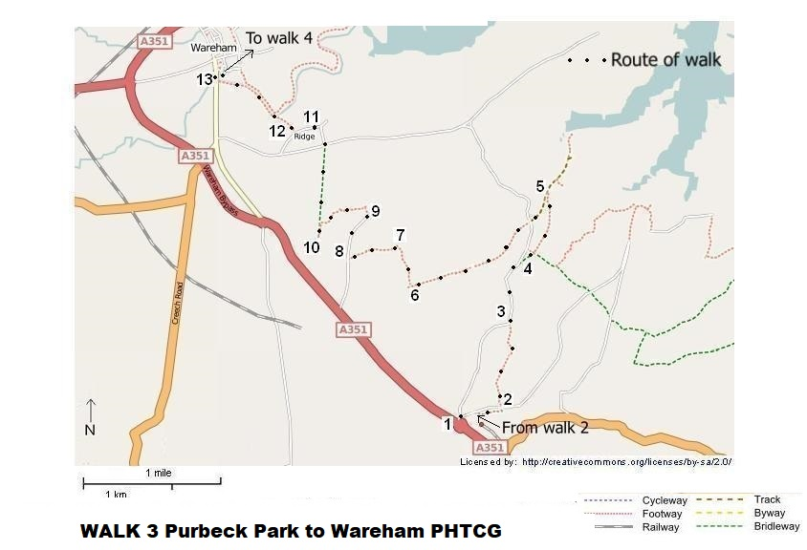

Map reproduced from http://www.openstreetmap.org/index.html

Revised 2/12/22

