WALK 2: GREENLANDS TO PURBECK PARK formerly NORDEN PARK-AND-RIDE

Ordnance survey map: OL15 Grid reference: start SZ 025 843 finish SY 954 828
Transport (check current timetables):
Bus: Purbeck Breezer 50 Bournemouth/Swanage, 40 Swanage/Poole and 60 Poole/Sandbanks.
South West Trains: Poole, Bournemouth, Wareham stations
Swanage Railway: Purbeck Park.
Car Parking: Studland Ferry Terminal and Purbeck Park.
Approximate distance: 11 km, 7 mls allow 4 hours.
Countryside Code: always follow the Countryside Code. Check online for latest version.
Facilities en route: toilets at Studland Car Park and at Purbeck Park. Café at Purbeck Park when trains are running.
Nature of route: footpaths and tracks through fields/woods; a few stiles.
Special interest: Sharford Bridge.
Connecting trails: South West Coast Path.
Connecting harbour walks: Walk 2a - Greenlands Farm, Agglestone Rock and Studland; Walk 2b – Studland Heath, Shell Bay and harbour’s edge.
Note: a compass would be useful.

- Leave the 50 Bournemouth/Swanage bus at the bus stop known as Goathorn Farm 1¾ miles from the ferry and take the gravel track signed to Ower and Norden (NW). There are frequent fingerposts indicating Ower and Norden along your route until you leave the bridleway at point (6) below.
- After about 1 km bear left with Greenlands Farm (National Trust) on your right, then in 60 m bear right (W). Keep straight on, past a metal barrier across the path.
When you pass over a small stream take the left-hand track, ignoring the one from the right which leads to Goathorn Farm and Point.

- Join the private road and turn left (W).
Follow the private road and take the bridleway on the right (NW). (This short section of private road follows the course of the old Newton Tramway, previously used in the transport of ball clay to Goathorn.)

- As you approach Newton cottages a small bridleway sign indicates that you should fork left. After 50 m, turn right and follow the grassy bridleway out into the open.

- Follow the bridleway across passing an entrance to Ower farm on the right. Go through a field gate and turn left onto a track.
At the four-way junction (you could turn right here and follow the track and right of way to Ower Point on the edge of the Harbour) go straight ahead (SW).

- Take the first path on the right. Coming to a road, turn right and very soon turn left onto a footpath
- At the junction of paths take the first right up the grassy track and into the wood. Take the left fork at the fingerpost and ignore the next right fork. At the T-junction, bear right and continue through the gate on to a private road.

- At the road turn left towards Wytch Farm (W). Continue down the road, passing the oil rig on your right.

- Turn right into Wytch farm through a gate. Keep to the hedge on your left until you almost reach the far corner. Turn left through the gateway and take the lane leading into the farmyard.
Go ahead through the farm, ignoring a tarmac lane to the left and forward through another gate. In 30 m take the enclosed grass track on your left (WSW).
Follow the track until you meet other tracks. Take the second to the left leading out into open ground.
Follow this around to the right ignoring the track coming in from the left alongside the woods.
- Coming to a Private Fishing sign pointing left, continue ahead through a hand gate and go straight up on to, and over, a mound. Continue straight on across the field and then bear right towards the stream and Sharford Bridge.
- Pass over the bridge and go ahead towards another bridge over a small stream. Cross the bridge and go up the path to come through a gate and out onto open ground.
Bear left and follow the track across to the road (SW).
- Note that this walk connects with Walk 3 in this series here. Walk through a gap ahead on to the road and pass the entrance to a private drive. Continue along until the road (S) turns sharp right. Go through the gate (S) ahead and follow the footpath waymarks and stiles. You will go through woods and across open fields to eventually join a private road.
- Take the footpath on the opposite side of the road through some trees and across a boardwalk. Soon you come to a small gate on your right leading into the Purbeck Park car park. Head across the car park, keeping the station on your left until you come to the car park entrance.
- Turn left (W) onto the road to go down to the A351 and turn right to catch the 40 Swanage/Poole bus.

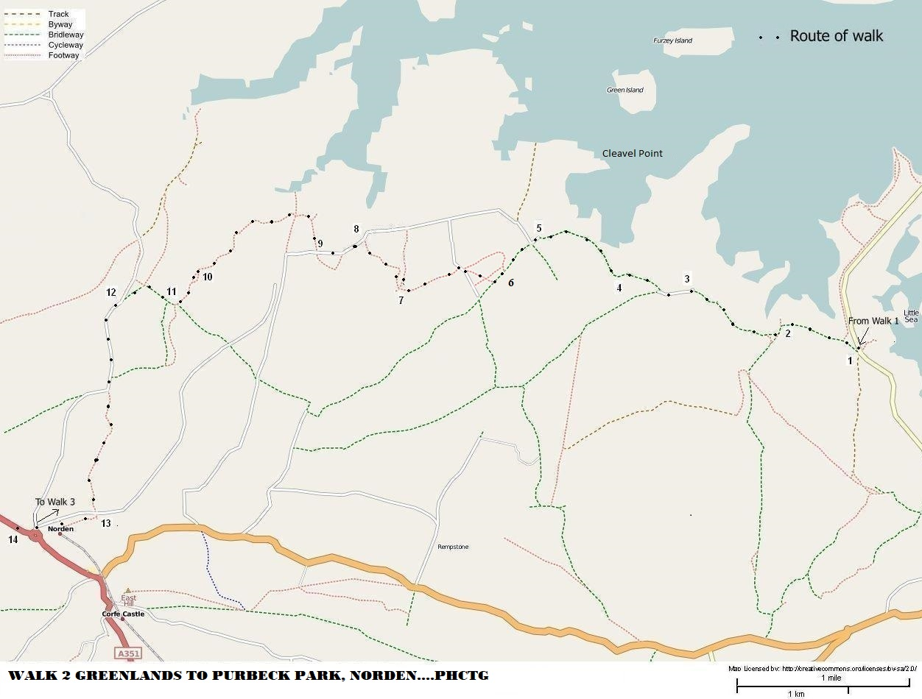
Map reproduced from http://www.openstreetmap.org/index.html
Revised 29/10/21

